**Git and GitHub Assignment**

**Step-1**

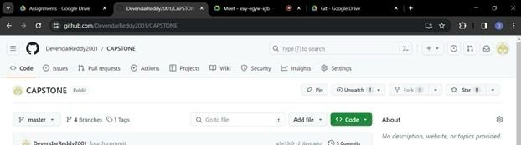

1. Created a new repository on GitHub named "CAPSTONE."
2. Copied the repository URL.
3. Created a file and initialized using git init command and created 3 txt files using touch cmd with git add and git commit we have successfully commited a file and established a connection between git and git hub pushed a file from local to remote repository using push cmd Locally, navigate to the project directory

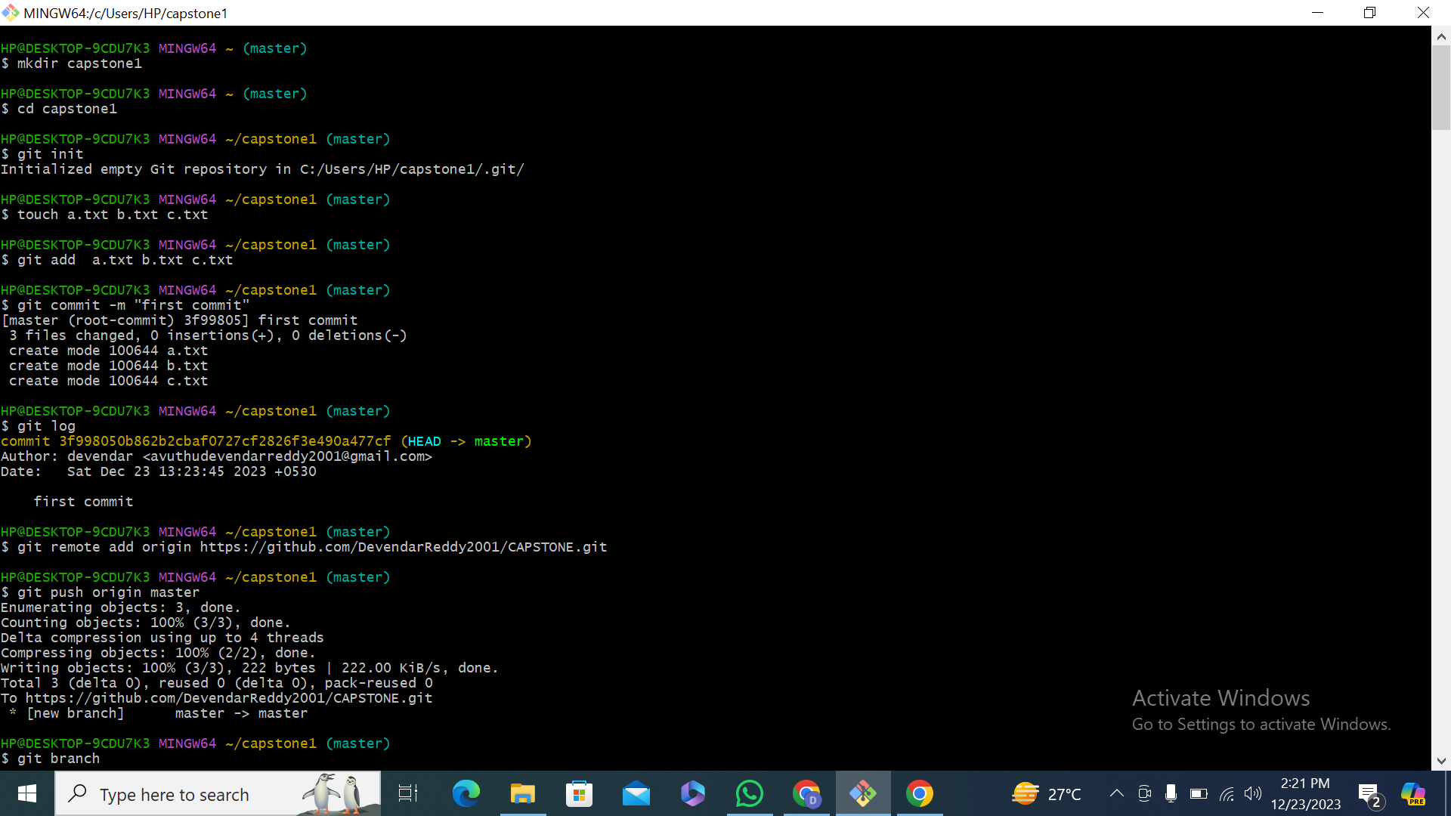

**Step-2-3 (Sohan , Ram, Push, Merge)**

1. Created a Branches for Sohan(git branch sohan) and Ram(git branch ram)
2. First in a sohan branch we created 3 txt files and and successfully commmited .
3. Using git push origin sohan,the files we created will be moved to git hub branch and the sohan branch is created.
4. Git check out master ,switched to branch master.
5. In the master we merged sohan.
6. Git push origin master with this what ever files we created will be there in the master

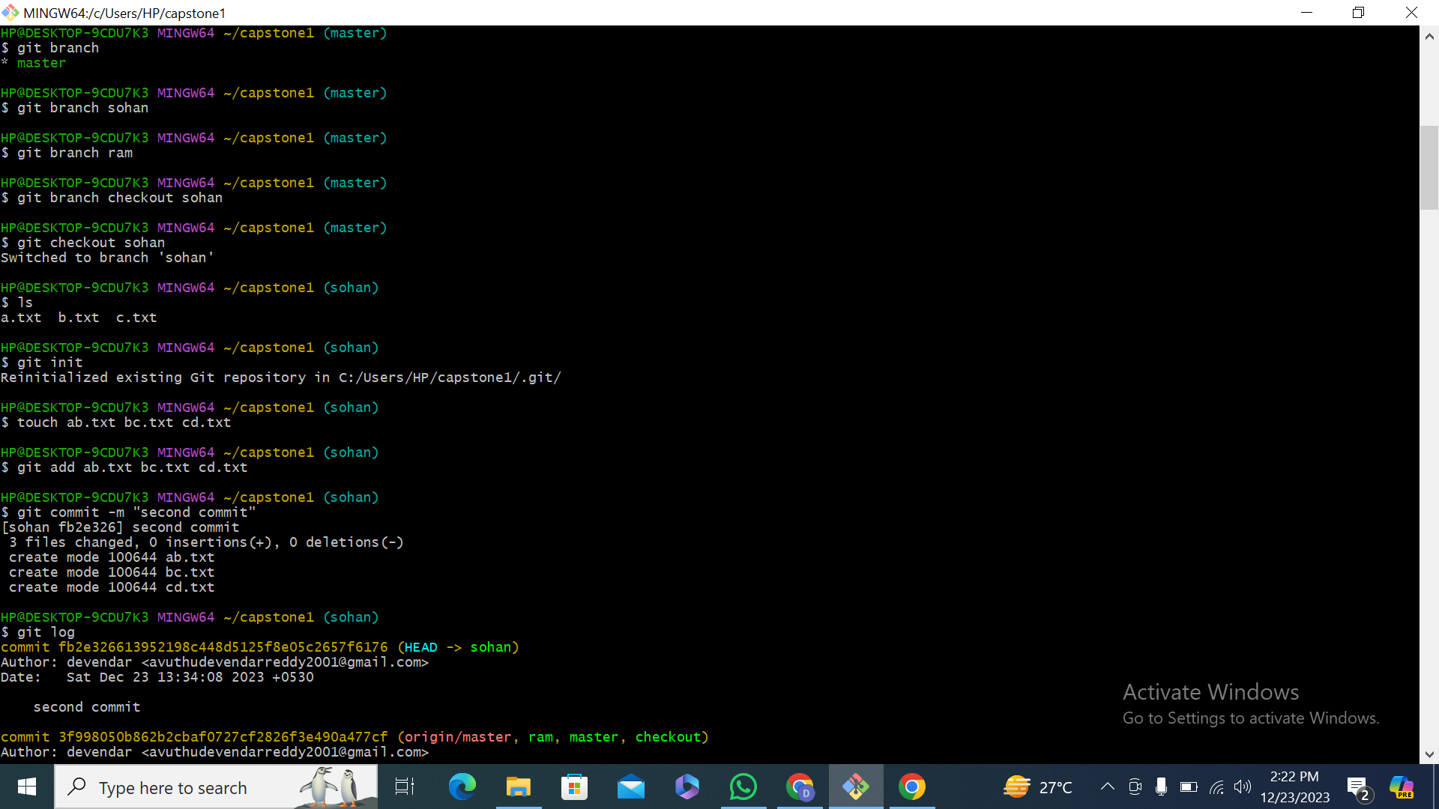

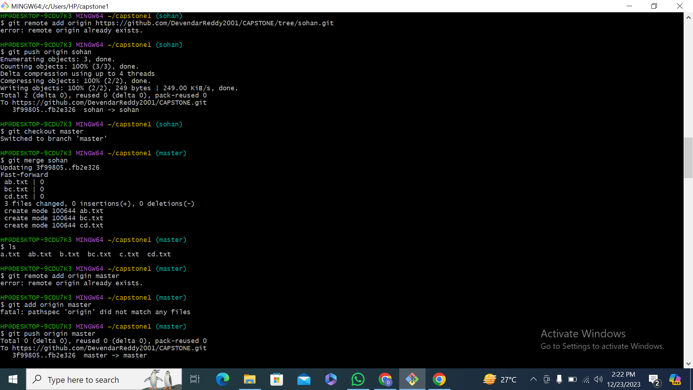

Same for ram branch

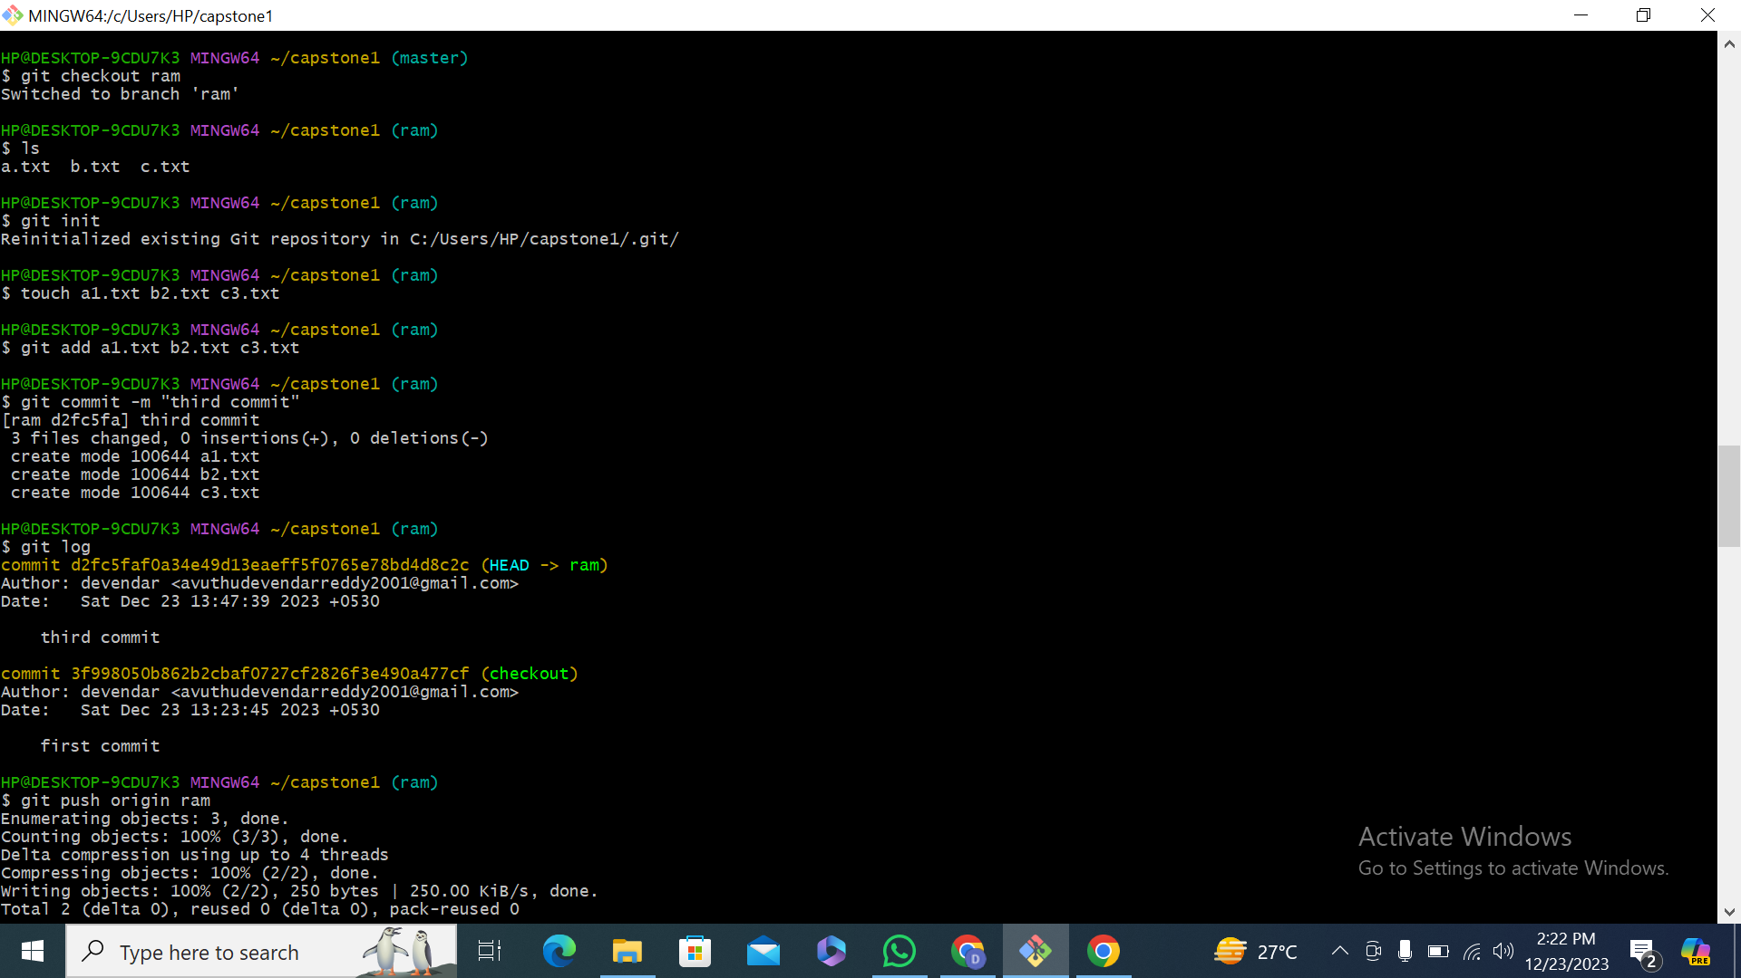

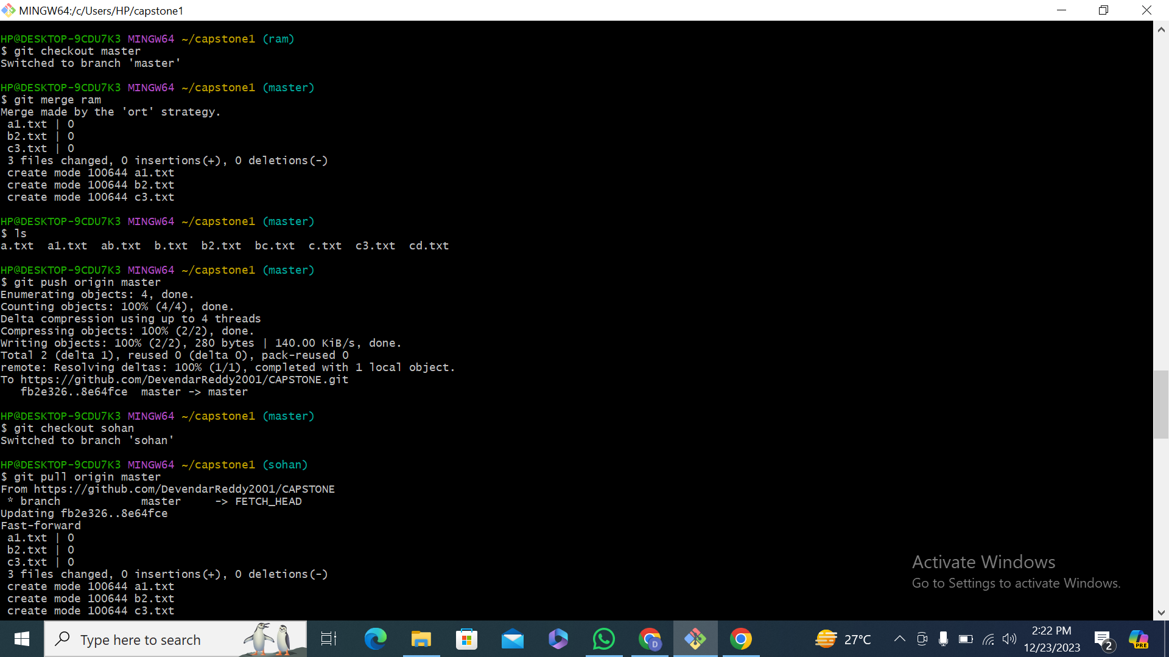

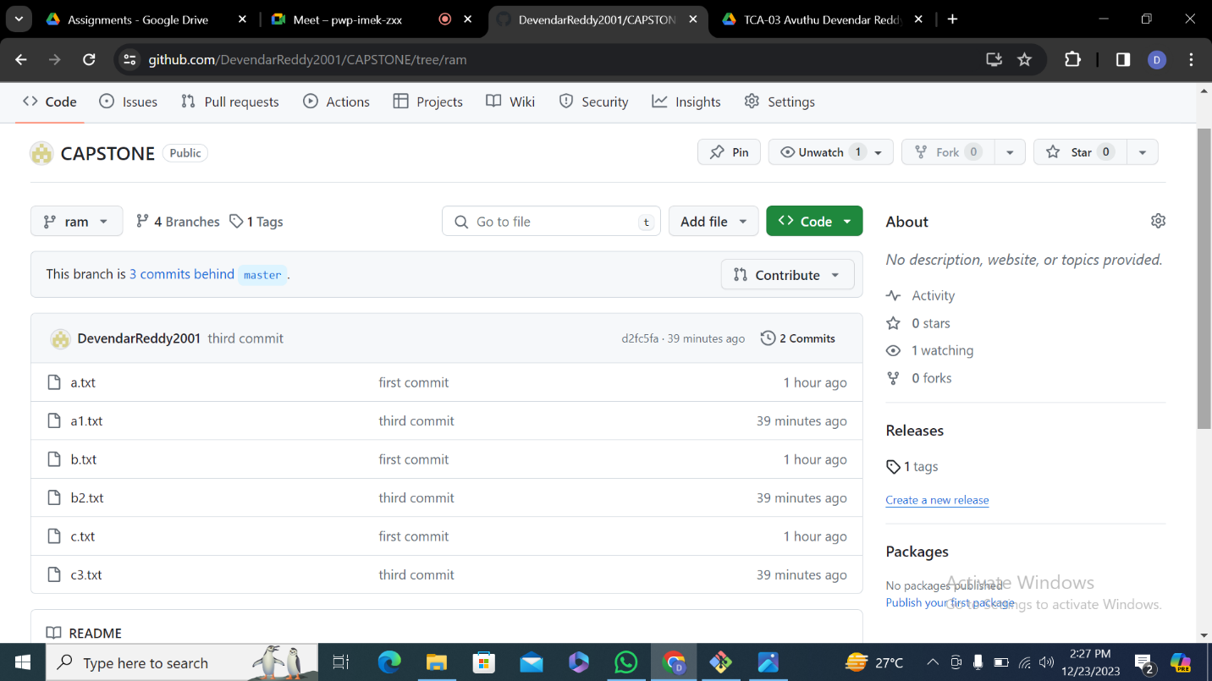

**Step-4**

1.Sync Sohan's Branch with Master

2.Switch to Sohan_branch

3.Pull latest changes from master(git pull origin master)

4.Push changes to Sohan(git push origin sohan)

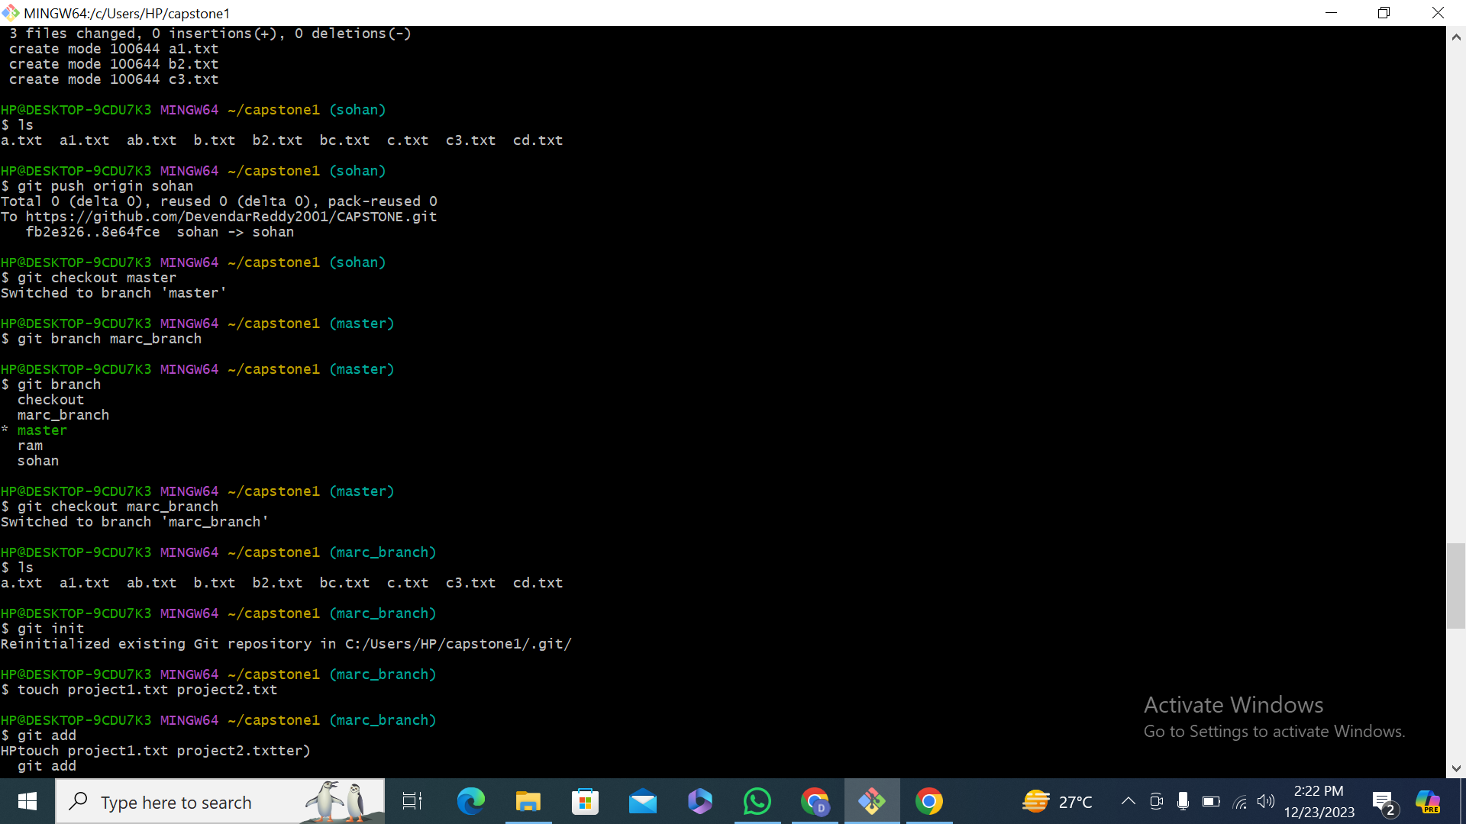

**Step-5 : Marc Setup**

1.Create git branch marc_branch.

2.created a 2 txt file init using touch cmd and added and commited successfully.

3.git push origin marc_branch.

4.git check out master switched to master.

5.git merge marc_branch and git push origin master



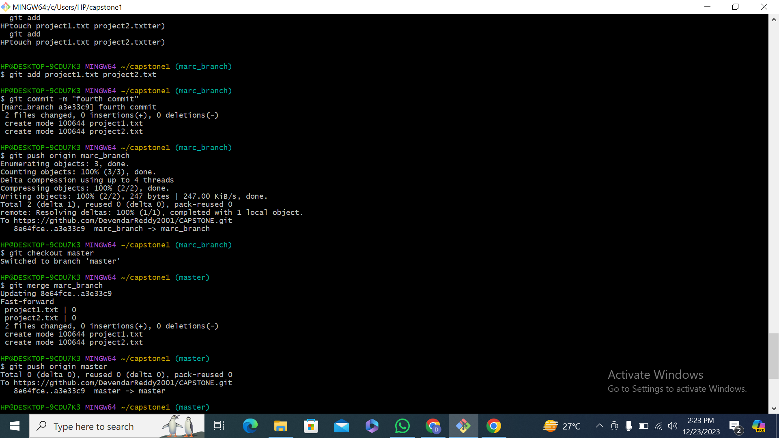

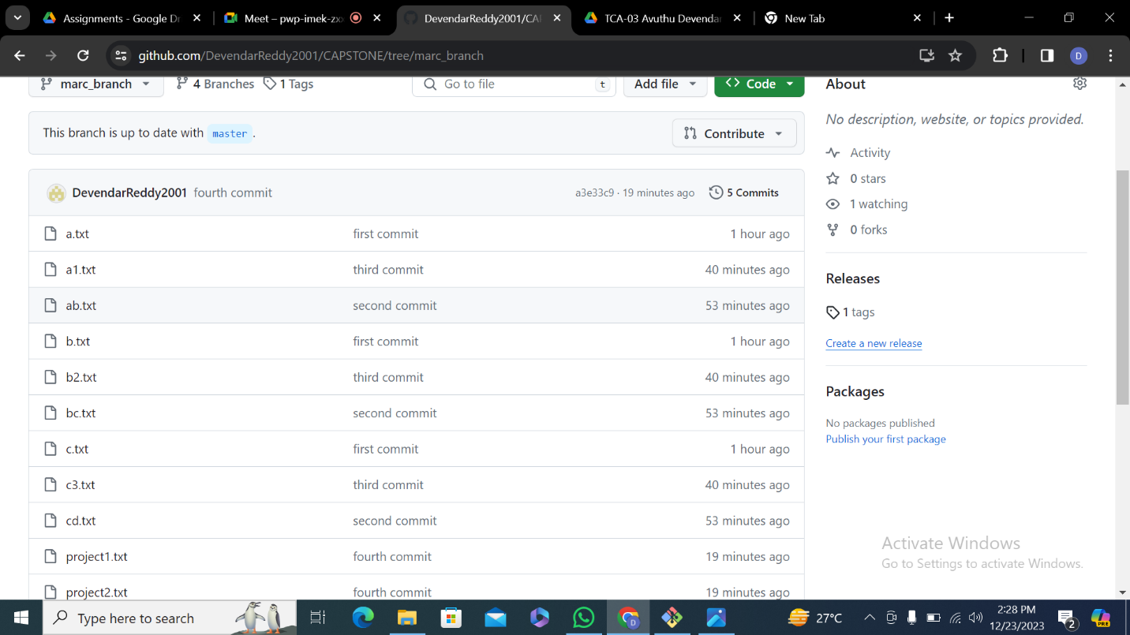

**Implement version 5**

Git tag [tag name] 